**Bahria University, Lahore Campus**

Department of Computer Sciences

Lab Journal 10

**(Fall 2023)**

|  |  |  |
| --- | --- | --- |
| Course: | **Database Management System Lab** |  |
| Course Code: | CSL 220 | Max Marks: |
| Faculty’s Name: |  | Lab Engineer: |

Name: ____________________________________ Enroll No: _______________________

**Views**

**SQL Updating a View**

You can update a view by using the following syntax:

**SQL CREATE OR REPLACE VIEW Syntax**

CREATE OR REPLACE VIEW view_name AS

SELECT column_name(s)

Now we want to add the "Category" column to the "Current Product List" view. Wewill update the view with the following SQL:

CREATE OR REPLACE VIEW [Current Product List] AS

SELECT ProductID,ProductName,Category

FROM Products

WHERE Discontinued=No

**SQL Dropping a View**

You can delete a view with the DROP VIEW command

**SQL DROP VIEW Syntax**

DROP VIEW view_name

**Consider the following schema**

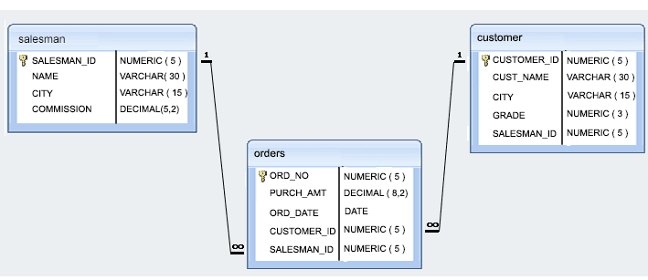

**Task 1**

* Write a query to create a view for those salesmen belongs to the city New York.

CREATE VIEW NewYorkSalesmenView AS

SELECT *

FROM salesmen

WHERE city = 'New York';

* Write a query to create a view for all salesmen with columns salesman_id, name, and city.

CREATE VIEW AllSalesmenView AS

SELECT salesman_id, name, city

FROM salesmen;

* Write a query to find the salesmen of the city New York who achieved the commission more than 13%.

CREATE VIEW HighCommissionNYView AS

SELECT salesman_id, name, city, commission

FROM salesmen

WHERE city = 'New York' AND commission > 0.13;

* Write a query to create a view to get a count of how many customers we have at each level of a grade

CREATE VIEW CustomerGradeCountView AS

SELECT grade, COUNT(*) AS customer_count

FROM customers

GROUP BY grade;

**Task 2**

* Write a query to create a view that shows for each order the salesman and customer by name.

CREATE VIEW OrderDetailsView AS

SELECT o.order_id, s.salesman_name AS salesman, c.customer_name AS customer

FROM orders o

JOIN salesmen s ON o.salesman_id = s.salesman_id

JOIN customers c ON o.customer_id = c.customer_id;

* Write a query to create a view that finds the salesman who has the customer with the highest order of a day.

CREATE VIEW HighestOrderSalesmanView AS

SELECT

o.order_date,

s.salesman_id,

s.salesman_name,

c.customer_id,

c.customer_name,

o.order_amount

FROM

orders o

JOIN

salesmen s ON o.salesman_id = s.salesman_id

JOIN

customers c ON o.customer_id = c.customer_id

WHERE

(o.order_date, o.order_amount) IN (

SELECT

order_date,

MAX(order_amount) AS max_order_amount

FROM

orders

GROUP BY

order_date

);

Task 3

* Write a query to create a view that shows all matches of customers with salesman such that at least one customer in the city of customer served by a salesman in the city of the salesman.

CREATE VIEW CustomerSalesmanMatchView AS

SELECT

c.customer_id,

c.customer_name,

c.city AS customer_city,

s.salesman_id,

s.salesman_name,

s.city AS salesman_city

FROM

customers c

JOIN

salesmen s ON c.city = s.city;

**Task 4**

* Write a query to create a view that shows the number of orders in each day.

CREATE VIEW OrdersPerDayView AS

SELECT

order_date,

COUNT(*) AS order_count

FROM

orders

GROUP BY

order_date;

* Write a query to create a view that finds the salesmen who issued orders on either August 17th, 2012 or October 10th, 2012.

CREATE VIEW SalesmenOrdersView AS

SELECT DISTINCT

s.salesman_id,

s.salesman_name

FROM

salesmen s

JOIN

orders o ON s.salesman_id = o.salesman_id

WHERE

o.order_date = '2012-08-17' OR o.order_date = '2012-10-10';

**Lab Grading Sheet**

|  |  |  |  |
| --- | --- | --- | --- |
| **Task** | **Max Marks** | **Obtained Marks** | **Comments(*if any*)** |
| 1. | 10 |  |  |
| 2. | 10 |  |  |
| 3. | 10 |  |  |
| 4. | 10 |  |  |
| **Total** | **40** |  | **Signature** |

**Note : Attempt all tasks and get them checked by your Lab. Instructor**

**Helping Material**

CREATE TABLE ABC

(

EMP_ID INT NOT NULL,

EMP_NAME VARCHAR (20) NOT NULL,

DEPT_ID INT NOT NULL,

DEPT_NAME CHAR (25) ,

DATE_OF_JOIN DATE

);

**How to create a view**

CREATE VIEW first­_view

AS

SELECT EMP_ID, EMP_NAME

FROM ABC;

**How to update a view**

UPDATE first_view

SET EMP_ID = 35

WHERE EMP_NAME ='Ramesh';

**How to delete a view**

DELETE FROM first_view

WHERE EMP_NAME = 'SAADIA';

**How to drop a view**

DROP VIEW first_view;